**COVID DATA ANALYSIS:**

Corona Virus Disease (Covid 19) is caused by severe acute respiratory syndrome coronavirus 2 (SARS-CoV-2). It was first discovered in Wuhan on 30th December, 2019. In India the first case was reported on 30-01-2020 in Kerala. At present in the world India has the second highest number of confirmed cases. It’s been 1 year 8 months and still many from entire world are suffering due to this pandemic. Many lost their employment, their loved ones and faced many difficulties which they have not even imagined in their lives. There were so many children who lost their parents, there were many parents who lost their children. Governments have taken various measures for the pandemic to break the chain of disease spreading. They were lockdowns imposed in many places which restricted people not to come out of their houses, gather around and not cause the spread of deadly virus. They were many pharma-companies which strived for the preparation of Covid Vaccine and succeeded in controlling the effect of virus in human body.

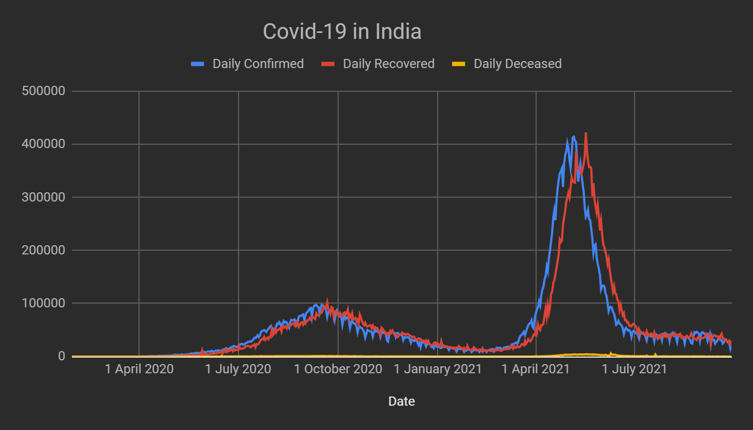

Newly Confirmed Cases per Day:

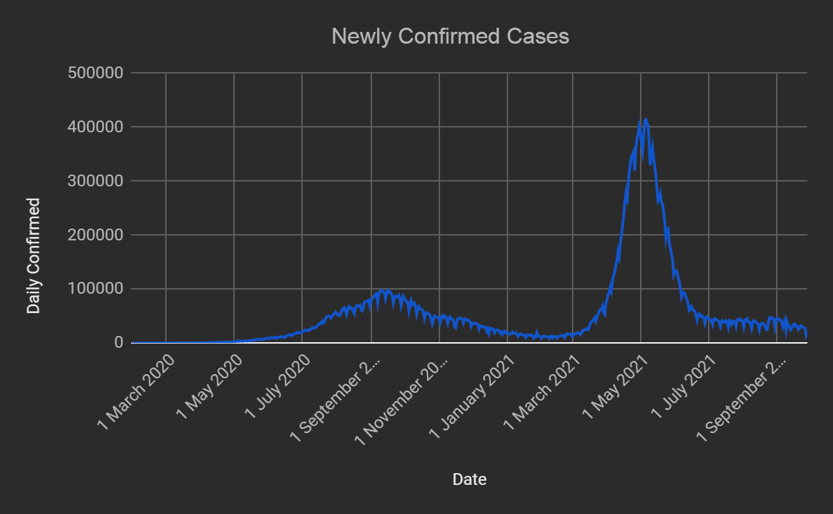

India has gone through two phases of Covid 19. The first phase of Covid 19 occurred during the month of September 2020. Daily confirmed cases have been rapidly increased from day to day and daily cases crossed 90,000 during this period. There was a huge outbreak of Covid in second wave during April 2021 to June 2021 and confirmed cases reached its peak by crossing the 4,00,000 confirmed cases per day during this period. There are multiple factors that have been contributed to the sudden spikes in cases such as lack of preparations of hospitals, new facilities are not built, poor implementation of rules and many more. The graph is left skewed.

Maximum number of confirmed cases per day: 4,14,280 cases on 6th May 2021.

Minimum number of confirmed cases per day: 0 cases during Feb 2020.

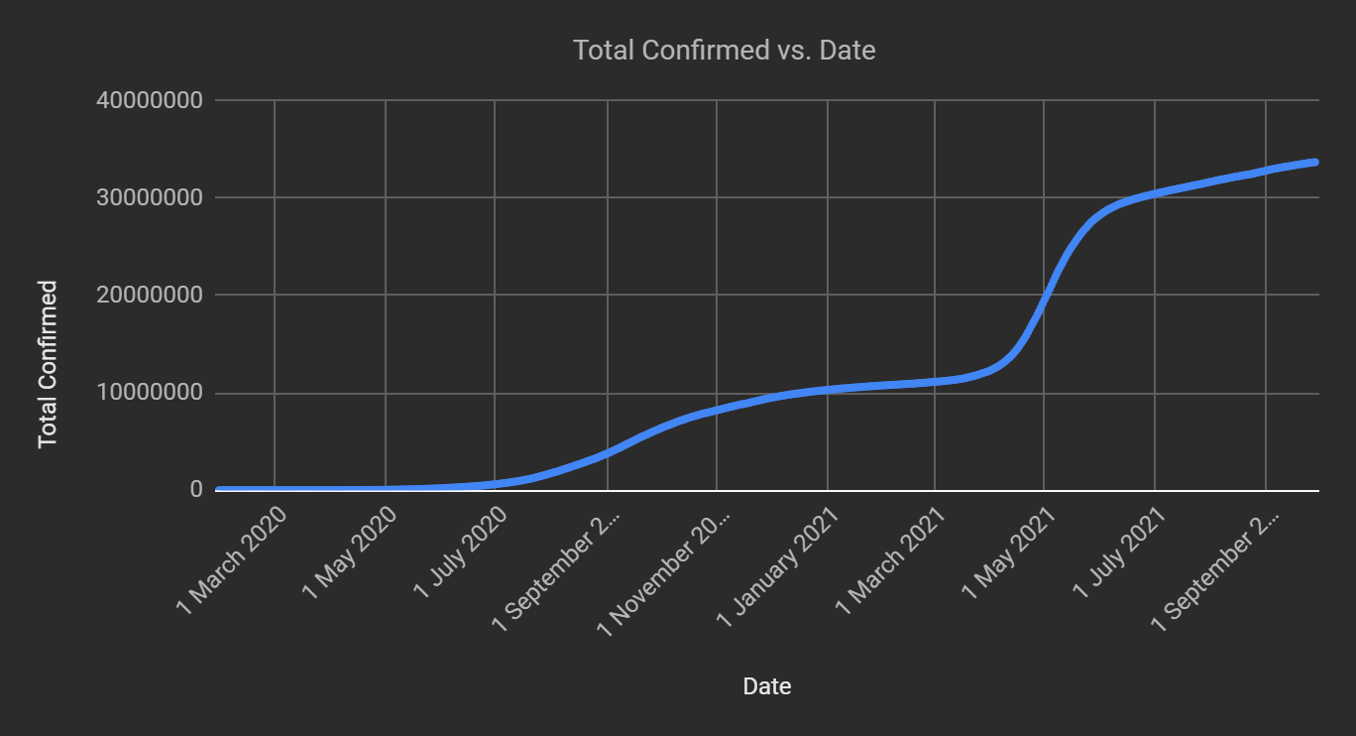

Total Number of cases confirmed till 28-09-2021: 3,37,14,828 people.

Newly Recovered Cases per Day:

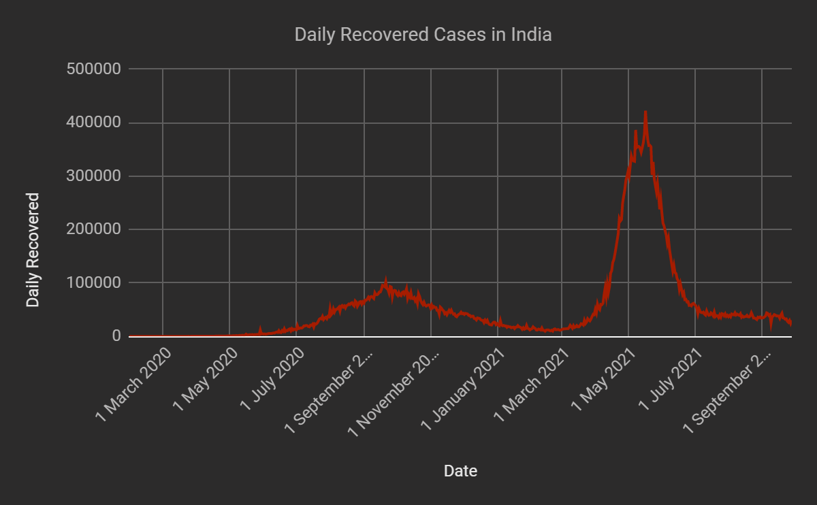

Most of the Indian people are not conscious about their health and don’t strive to have a healthy food and life. Many are not capable of surviving from the Covid due to their weak immune system which couldn’t fight enough with the virus. India got its first vaccination after a year of starting the pandemic and these vaccines helped the people to get less effected by virus and helped many to boost their immune and fight back. They are many who donated their plasma after their recovery from Covid in order to help the others who are suffering. At present India has recovery rate of almost 97.82%. The graph is left skewed.

Highest number of people recovered per day: 4,22,391 on 17th May 2021.

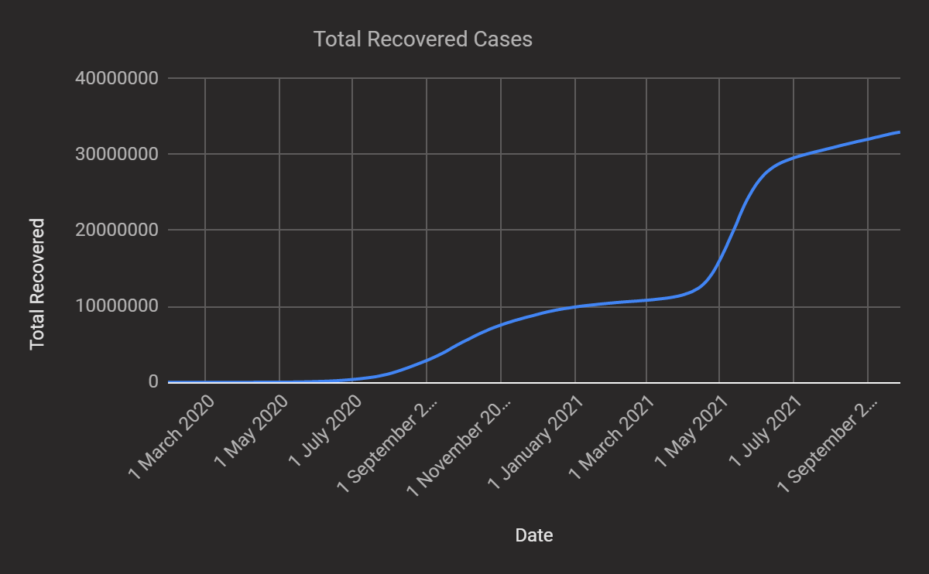

Total Number of recovered cases: 3,29,78,439.

Recovery Rate = (Total recovered cases) / (Total confirmed Cases)

= 32978439/33714828 = 97.82%

Newly Deceased Cases per Day:

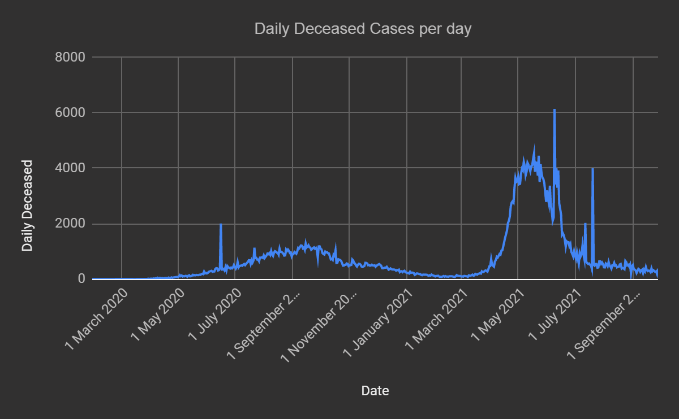

During the late June 2020 India has reached 2000 deaths per day and after that we can see a slight decrease in the count of the deaths. First wave in India occurred during September 2020 and at this time we can observe 1100 to 1200 deaths per day. After this again there is a downfall of number of deaths per day. During the second wave deaths have even crossed 6000 per single day. The average deaths per day are 735 during the period from January 2020 to September 2021. The graph is left Skewed.

Highest number of deceased per day: 6139

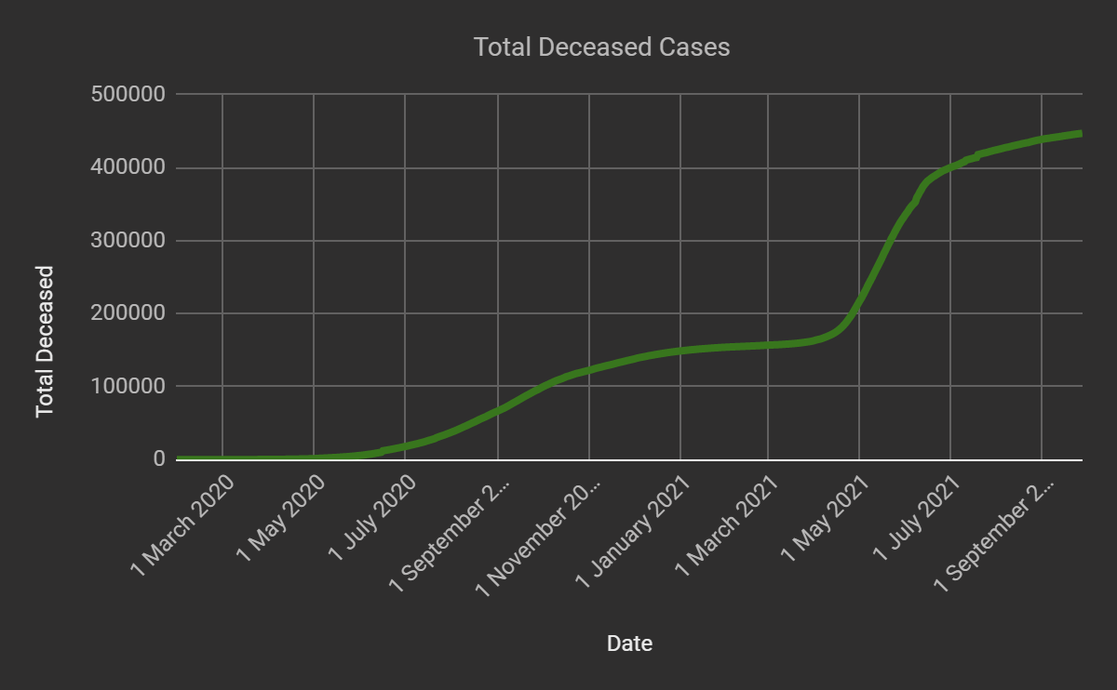

Total Number of deaths till date: 447191 cases.

Death Rate = (Total deceased cases) / (Total confirmed Cases)

= 447191/33714828 = 13.28%

Graph plotting total confirmed, recovered and total deceased cases:

